**PF LAB 06 TASKS**

**Name: Muhammad Rohaan Roll No: 25K-0026**

**Date: 26th September, 2025 Section: BAI-1A**

**-> TASK #1:**

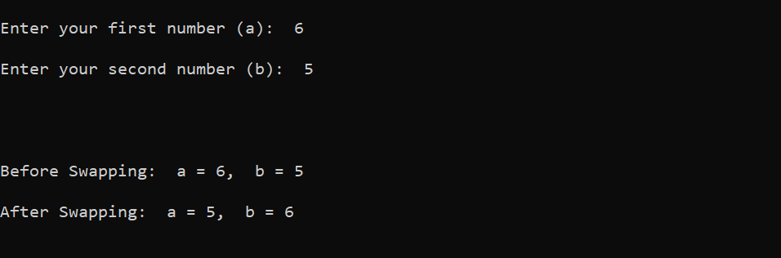

______________________________________________________________________________

**-> TASK #2:**

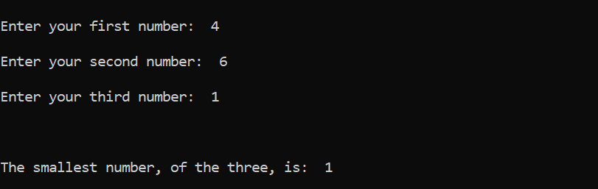

______________________________________________________________________________

**-> TASK #3:**



